Prep Meeting 23

# SEM (Continued).

**Means**

**Median**

*Follow-Up:*

* Do some more experiments to get more confident results, up to 100 dimensions, further seems quite impossible for NOTEARS. (Done)
* Try different sparsity levels (now we have 2p edges per variable, but NOTEARS also tried 4p). (Done)
* Try different graphs (NOTEARS also tried scale-free graphs).
* Different additive noise distributions (NOTEARS also tried Exp, and Gumbel). Could also try uniform noise, etc.
* Compare other methods? NOTEARS claims to outperform other methods, but perhaps it is also interesting to include other methods? E.g. LiNGAM, although that one explicitly says that noise is *not* Gaussian.
* Different regularizer for OMP. For now, we just did edge threshold, but perhaps we can try something different? I expect this regularizer to achieve very good FPR and TPR, since the regularizer exploits the knowledge that our coefficients are > 0.5.

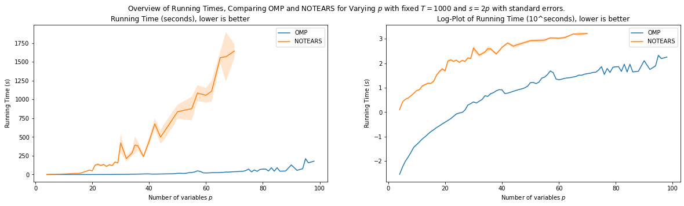

**Speeding up OMP**

*QR Decomposition using Modified Gram-Schmidt:* Still need to invert p x p matrix, which can be costly in high dimensions. Read a paper that talks about doing a QR decomposition to compute the pseudo inverse or information matrix. This can be done best using a modified Gram-Schmidt procedure. I need to investigate how fast this is, and whether this works with an already “summarized” matrix Psi, where we only store inner products.

*Checking for DAG-ness*. Checking for DAG-ness is not very fast now. I checked it and sped it up a bit. Although it was naïve, not very much gain here, as it is O(p^2). Now two methods for checking DAG-ness, one method has three methods.

*Early stopping*. We do not need to continue until we have a full DAG. Especially for large dimensions, a large portion of coefficients will have a very small gain, so when all edges have a gain below tol, we can stop. I tried putting this at 0.5, and it seems we have gained quite some time while not losing any accuracy.

**Google Colab**

Have a server doing these experiments for me.

# Regularization

# Regularizations for VAR data

**Formalized Some Regularization Methodologies.**

## Regularization Performance Measures

### Predictive Performance Measures

**Mean Squared Error on Test data**.

We sample again some test data, or we set aside some data for test data. “Set aside test data” is difficulty for time series, but 1-step-dependent VAR models should be doable.

**Mean Squared Error in Population Setting**

Some time ago, we derived that when data is generated by W_true, the expected mean squared error using W_est is equal to, 

Where Sigma_X is the unconditioned covariance of the time series, and Sigma is the covariance of the additive noise at each time step.

We also know that W_true is the unique global minimizer of the mean squared error. So we can also subtract this quantity and simply focus on

We then check how close we can get this quantity to zero for a given regularization method.

### Structural Performance Measures

**Area Under Curve**.

Ideally, we want a regularization procedure that works as follows:

* As we increase the degree of regularization, we prevent **overfitting**. We hope to first filter out untrue edges. This will decrease that false positive rate, and leave the true positive rate untouched. We hope to find a point where we have filtered out *all* untrue edges (so FPR = 0), yet we have not filtered out *any* true edges (so TRP stays maximal).
* If we continue to increase the degree of regularization, then we will regularize too much, we **underfit**. We will then also start filtering out true edges, thereby decreasing the TPR.

For each threshold value tau, we get a FPR and a TPR. When we plot these pairs (FPR, TPR) as a function of tau, we get what is called an ROC-curve. Such an example is given below.

[[ 0.17 0. 0. 0. ]

[ **0.5** 0.05 0. 0. ]

[ **0.46** -0.09 **-0.57** 0. ]

[-0.12 **-0.43** **-0.44** 0.07]]]

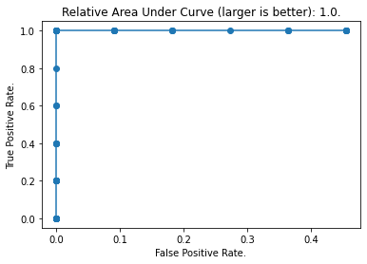

We see that for a threshold of 0, we have a large TPR, but also a large FPR. Then, as we start regularizing, we see that we are doing a good job! We first remove the untrue edges, thereby decreasing the FPR without decreasing the TPR. Then, at the top-left corner. We have done a perfect job, we have found a threshold such that the TPR = 1.0, and the FPR = 0.0.

Afterwards, when we continue to regularize, we see that we start filtering out true edges as well, thereby decreasing the TPR.

The difficult key is knowing when we have reached a good threshold, but this graph can be useful in comparing different methods when we have a ground truth. Such a quantity can for example be the Area Under Curve, which is also used often in machine learning, albeit in a different setting.

Regularization methods such as these:

* Coefficient size.
* Increase in MSE per edge.
* Increase in
* Bootstrapping

Such an ROC curve can also be used to find an “optimal” threshold if we know how much value we should attach to a true positive, as compared to a false positive.

Normally we can use cross-validation and get something like this. However, we do not really have a ground truth.

# Midterm Proposal

Wrote down the midterm proposal, beginning was quite retrospective.

# Proof into OMP for SEM

Been gathering some sources for guarantees on the OMP with noise. There are a lot if papers with names like “exact recovery conditions for OMP”.

OMP without noise:

<http://users.cms.caltech.edu/~jtropp/papers/Tro04-Greed-Good.pdf>

OMP with noise:

<https://math.mit.edu/~liewang/OMP.pdf>

<https://arxiv.org/pdf/1905.12347.pdf>

<https://cradpdf.drdc-rddc.gc.ca/PDFS/unc362/p813262_A1b.pdf>

# Garvesh Raskutti Twitter Data

Found the dataset, but their preprocessing was quite intense.